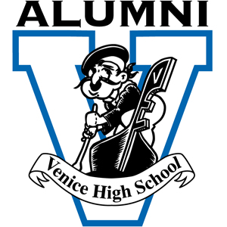

Venice High School Alumni Association Gondolier of the Year Award
Criteria

The Venice High School Gondolier of the Year Award was established in 2011 by the Venice High School Alumni Association to honor people who would serve as role models to students by their examples of outstanding leadership, achievements and service to Venice High School, the Alumni Association or the community.

Inductees are recognized in November with a special dinner in their honor and at the Venice High School Homecoming Football Game.

Nominations are welcome ANYTIME. Go to the Alumni Website: venicehighalumni.com and click on Alumni Annual Awards.

Nominations may be made by anyone for any person who has performed a service relating to Venice High School or the community.

Nominees do not have to be a graduate of Venice High School. Nominees may be living or deceased.
The nominees must have performed a service over a prolonged period of time or chaired an event of significant importance for the welfare of Venice High School students, the Alumni Association or the community.

The Venice High School Alumni Board of Directors will make the final selections.

All nominations submitted will be reviewed on an ongoing basis and remain on file with the Venice High School Alumni Association for future consideration.

The nominator is encouraged to attach supporting documents to the nominating form. Deadline for submitting a nomination for this year’s award will be June 1st.
Nominations must be submitted on the Venice High School Alumni Association’s nominating form to:

Venice Alumni Association
2435 Walgrove Ave.
Los Angeles, CA 90066

Attention: Craig Jaffe – Awards Chair craig@jaffeinsurance.com

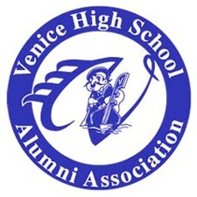
Venice High School Alumni Association Gondolier of the Year Award Nomination Form

The Venice High School Gondolier Award recognizes and honors persons who are role models and have contributed to the welfare of Venice High School students, Alumni Association or the Community.
The nominees must have performed a service over a prolonged period of time or chaired an event of significant importance that affected the students of Venice High School, the Alumni or the Community.
Nominations may be submitted all year long to the Alumni Awards Coordinator, but no later than June 1st to qualify for this year’s recognition.

Nominee:
First: MI Last Address: Phone: e-­‐mail

Affiliation with VHS VHS Graduate Year
(Indicate all that apply) VHS Teacher From to
VHS Alumni Assoc. From to Other Activity Community Involvement

Venice High School or Alumni Association involvement (brief description)

Community Involvement ( brief description)

Additional comments: awards received, organizations, hobbies, etc.

Please attach any supporting material: Newspaper, magazine articles, photos
Nominated by:
Address: Phone: e-­‐mail
Date of nomination:
All nomination forms and any questions or comments should be sent to:
Venice Alumni Association
2435 Walgrove Ave, Los Angeles, CA 90066
Attention: Craig Jaffe - Alumni Awards Coordinator craig@jaffeinsurance.com

